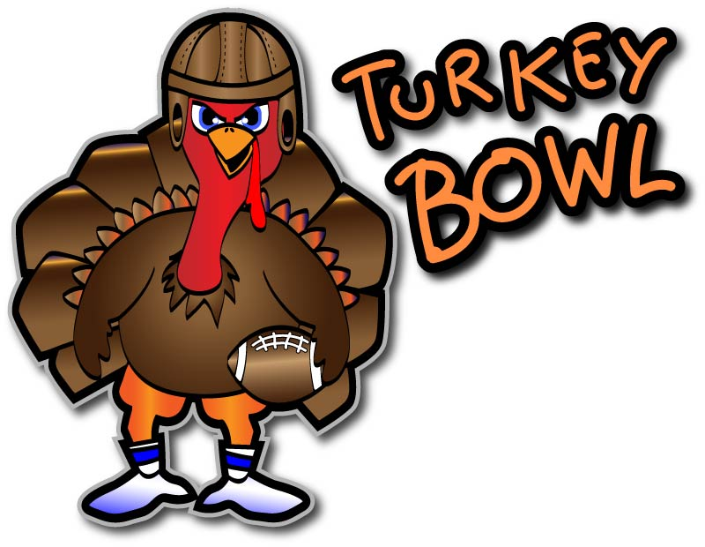
THURSDAY, NOV. 24TH
^{THANKSGIVING DAY}
SANDPIPER BAY
9:00AM SHOTGUN START
18 HOLES, CART, RANGE BALLS, & SKILL PRIZES

FIELD GOAL CHIPPING CONTEST!

MAKE YOUR OWN FOURSOME
CALL (910) 579-9120 TO SIGN UP TODAY

BRIDGESTONE & TEAM EFFORT GOLF BALLS

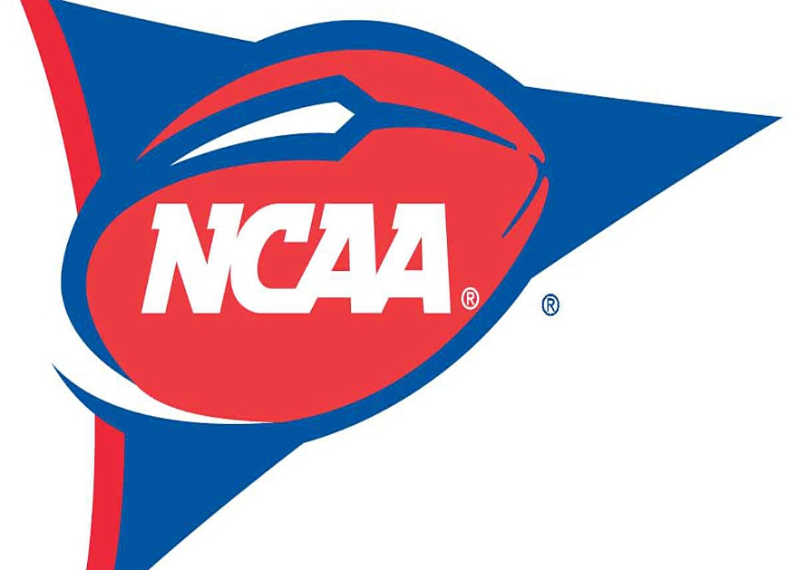
LOCALS & CARD HOLDERS $40
EACH PLAYER WILL RECEIVE TWO SLEEVES OF NCAA LOGO BALLS
CHOICE OF TEAMS WHILE SUPPLIES LAST;
- ALABAMA
- CLEMSON
- DUKE
- EAST CAROLINA
- GEORGIA
- FLORIDA STATE
- MARYLAND
- MICHIGAN
- MICHIGAN STATE
- NORTH CAROLINA
- NC STATE
- NOTRE DAME
- OHIO STATE
- PENN STATE
- SOUTH CAROLINA
- TENNESSEE
- WAKE FOREST
- WEST VIRGINIA
- VIRGINIA TECH

